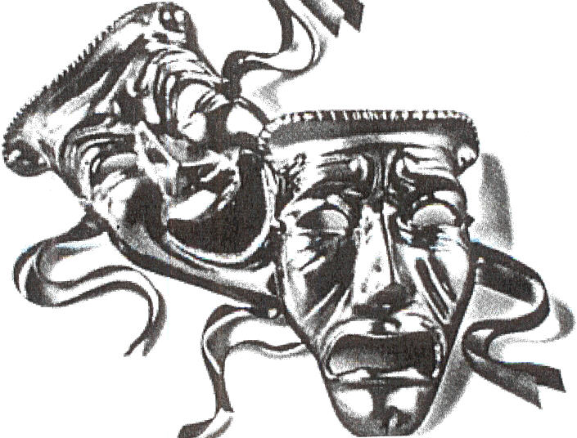
Alpha Psi Omega/Delta Psi Omega
FIVE STEPS TO (RE-)ACTIVATION

STEP 1: SELECT A FACULTY SPONSOR.
The sponsor should be a full-time faculty member in their respective Department of Theatre or Speech (unless the academic and production activities are in some other discipline). All correspondence is sent to the faculty sponsor unless they elect to do otherwise. Please send the re-activation form on the following page to businessmanager@alphapsiomega.org and webmaster@alphapsiomega.org

STEP 2: SELECT NEW CANDIDATES.
The faculty sponsor will supply the Business Manager with records of new candidates. Most chapters operate by point guidelines. A suggested point system is outlined in the National Constitution and can be adjusted to each chapter's needs.

STEP 3: CONDUCT AN INDUCTION CEREMONY.
The National Office will, upon request, make the faculty sponsor an honorary member and authorize him/her to induct the new members and elect officers. In order to do so, four (4) copies of the ceremonies book where the initiation ceremony is explained will be needed.

Once an initiation ceremony has been conducted, please send the initiation report to the National Office via email to businessmanager@alphapsiomega.org and webmaster@alphapsiomega.org with each individual's dues (paid once per member). We highly recommend doing this online. Membership cards will be mailed directly to the address you provide. PLEASE MAKE SURE YOUR ADDRESS IS CORRECT AND YOUR FACULTY SPONSOR’S NAME IS ON IT. Faculty sponsors become honorary members and are not required to pay dues.

STEP 4: ADOPT A SET OF LOCAL BY-LAWS BY WHICH YOU OPERATE.
The by-laws should include qualifications for membership and anything else that is relevant to your chapter. In most collegiate institutions, the administration requires that the constitution and by-laws of student organizations be deposited in the office of student affairs. The National Constitution can be used as a guideline in developing your by-laws. The National Constitution may be ordered from the National Office.

STEP 5: READ THIS GENERAL INFORMATION.
Charter - If you have lost your chapter's charter, you may purchase another one for $35.00. This is not required since you already have a chapter and charter at your school.

Supplies - Supplies are ordered from the National Office. Supplies available include pledge cards, membership cards, pin order forms, scroll, charter, National Constitution and Ceremonies Book, membership certificates, and a banner. All supplies are available from the website and may be ordered online.

Honorary - Alpha Psi Omega chapters are not normally producing organizations but are honorary and run simultaneously with the regular producing organization. Close cooperation and motivation for succeeding are essential for a smooth running and meaningful Alpha Psi Omega chapter.

For additional information, please contact:
Sally Story, National Business Manager, Alpha Psi Omega
Theatre Department, University of Arkansas – Fort Smith, 5210 Grand Avenue, Fort Smith, AR 72904
businessmanager@alphapsiomega.org
(RE)-ACTIVATION FORM
(Your chapter is officially inactive if in the past two years you have not initiated new members or you have not sent the names of new members and their dues to the National Office. No one is an official member unless their names have been recorded by the National Office and dues have not been paid to the National Office.)

DATE:__________________

Dear National Business Manager:

We would like to reactivate our cast of (check one):

______ALPHA PSI OMEGA (4-year schools)

______DELTA PSI OMEGA (2-year schools)

Contact information for the nascent chapter’s faculty sponsor:

NAME:_____________________________________

ADDRESS:__________________________________

___________________________________

___________________________________

PHONE:____________________________________

E-MAIL ADDRESS:___________________________

RETURN THIS FORM TO:
Sally Story
businessmanager@alphapsiomega.org

and

Joel Lord
webmaster@alphapsiomega.org

